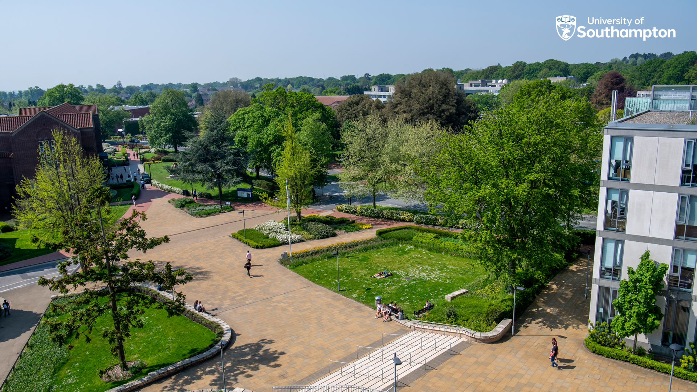

Short course in mentoring and developing beginning teachers

Portfolio template 2025-26

Unit 1: Foundation mentoring knowledge and skills

I confirm that I have completed Level 1 and Level 2 mentor training via the University of Southampton | Signed:  Date:
I have provided proof of this training via my mentor development log/attendance certificates in the specified format. | ☐ Attached document (mentor log and/or Level 1and Level 2 certificates).  ☐ Linked document (please paste link below)  LINK HERE:

Unit 2: Individualised application and reflection

Enhanced Directed Tasks | Title | Reflection task: approx. 300 words (or equivalent) each  (written or link to recorded version)
1
2
3
4
5

I confirm that the above submission is my own work.  I confirm that I have kept the identity of other individuals anonymous within this submission. | Signed:  Date:

