


ITAP Handbook for Schools: Adaptive Teaching
12^{th-} 15th April 2027
(In Main Placement schools on Wednesday 14th and Thursday 15th April)
PGCE (Secondary) Programme

Emily Henry: Associate Programme Director, PGCE Secondary.

Emily Henry

Introduction
ITAP was introduced by the government for all Initial Teacher Education programmes in England from 2023. The following key compliance requirements are taken from the DfE criteria which can be found here: https://assets.publishing.service.gov.uk/media/67d9a7caa87d546feeda01c4/Initial_teacher_training__ITT__criteria_and_supporting_advice_-_March_2025.pdf
- ITAP equates to 20 days and should be additional to the 120 days spent on general school placements. Beginning teachers therefore have an additional 100 hours of training (during the 20 days of ITAP) in their curriculum from 2024.
- ITAP content should be based on pivotal or foundational concepts of the planned ITT curriculum that are able to put into practice immediately and have potential to impact on classroom practice irrespective of context.
- It must be additional to and distinct from the general placement itself.
- The aim of ITAP is to enable beginning teachers to make clearer links between theory and practice in 3-5 key areas of the ITT curriculum. These areas should be focused in order to maximise progress.
It is important to emphasise that beginning teachers should only be involved in activities relating to ITAP during their time in school on these blocks.
Intent
ITAP is part of our PGCE curriculum and, whilst each block is distinct, the timings and format of each ITAP have been carefully designed to complement the phases of our wider curriculum, becoming increasingly nuanced as the year develops in line with models of beginning teacher development discussed during the Level 1 mentor training.
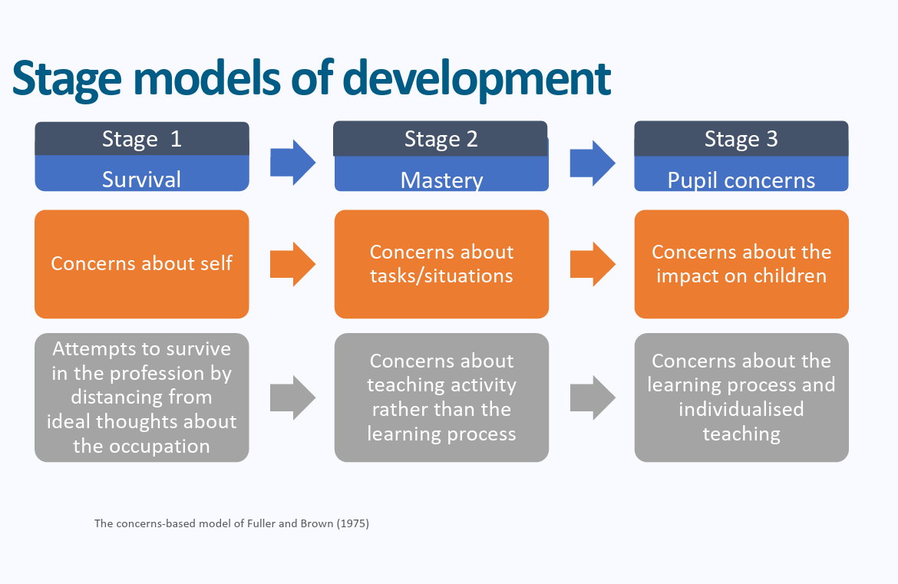
The Professional Studies curriculum starts in September with an overview of high-quality teaching and this is revisited throughout each ITAP. Whilst we look at specific areas of focus – for example EAL and SEND- the message that we hope to convey through ITAP is that teaching is not about learning how to ‘teach EAL pupils’ or ‘pupils with Autism’ in a particular way; the focus is on returning to what constitutes high quality teaching for all pupils and applying these to different contexts in order to ensure that beginning teachers are always refining their practice and maintaining high expectations.
Another key focus which runs throughout all ITAP blocks is the importance of language and communication. This begins with a focus on clear instruction in the behaviour ITAP and then progresses to a more specific focus on how assessment tasks are constructed in order to gain an accurate overview of learning; the SEND ITAP then continues to look at the importance of language in explaining tasks but also in terms of framing our expectations of pupils. In adaptive teaching the focus is on how teachers set high expectations for all pupils through returning to look at scaffolding and high- quality instruction through the lens of EAL learners; they expand on this by exploring how teachers plan for misconceptions. The final ITAP looks again at high expectations and quality first teaching, with a focus on at the importance of consistency of language in the transition to secondary school.
An overview of all ITAP blocks
Monday 28th September – Friday 2nd October: Behaviour with a focus on language, routines and presence. This ITAP looks in particular detail at the importance of routines and the clear language and presence needed to communicate these.
Wednesday 25th – Friday 27th November: Assessment for learning. At this point the focus is on where and how pupils are being assessed in lessons. Many beginning teachers have a range of AFL strategies by now, but this ITAP aims to deepen their understanding of precisely why they are using a particular method of assessment at each moment in a lesson. It also aims to get them to think deeply about how they are assessing pupils’ learning by focusing on the language used in assessment opportunities (the structure of MCQs, for example.)
Friday 5th, Monday 8th Tuesday 9th Friday 13th February: SEND. Focus on high quality teaching and ordinarily available provision. Again, there is a focus on language: both written and verbal and how this can be used in both instruction and discussion to effectively include, stretch and support all learners, including those with SEND. As part of this, there is also a focus on how TAs can effectively support pupils by supplementing support from teachers, again by looking at the language used.
Monday 12th – Thursday 15th April: Adaptive teaching: This builds on the previous ITAPs by again reinforcing the importance of high quality teaching as being critical for the success of all students. It will remind beginning teachers of the importance of formative assessment in informing adaptive teaching. They will focus on how teachers support pupils to achieve highly with particular emphasis on scaffolding and planning for misconceptions.
Wednesday 8th – Friday 11th June: Maintaining high expectations in Year 7. Again, there is an emphasis on high quality teaching and again, we return to a focus on language through looking at the potential for shared subject-specific vocabulary from KS2 at transition to enhance progress. BTs will be in their main placement schools for this on Thursday 10th June.

Adaptive Teaching ITAP.
Context and Important Elements to Signpost
An overview of the week is provided below:


Monday 12th April: On Campus

ITTECF Links: 1.3, 1.6, 1.8, 5.1-9, 6.1

Beginning teachers will attend the following sessions on a carousel. An overview of the session powerpoints can be found on the Partnership website.

Session 1, High Quality Teaching for EAL Learners
Beginning teachers will be reminded of the core principles underpinning high quality teaching through the lens of EAL learners. The session will look specifically at language in instruction, scaffolding and modelling for EAL learners and will therefore allow BTs to revisit some of the core ideas underpinning the SEND ITAP. This will be developed by looking at EAL learners in particular and will be further developed during the deconstruction phase by looking at how teachers support all learners to achieve high expectations.
ITAPs on the importance of consistent language and routines and of the importance of frequent, ongoing formative assessment of pupils, again, with a reminder of the importance of language particularly when considering pupils with SEND.

  - Session 2: Adaptive Teaching and Differentiation
This session will explore the definitions of adaptive teaching and what is meant by this. It will build on the pre-reading from the EEF: https://educationendowmentfoundation.org.uk/news/moving-from-differentiation-to-adaptive-teaching
https://educationendowmentfoundation.org.uk/news/scaffolding-more-than-just-a-worksheet
to explore how teachers can set challenging objectives and then structure their lesson so that all learners can achieve these rather than producing three or four separate lessons for different groups of learners. It will develop prior learning by discussing anticipation of misconceptions as part of the planning process.
Session 3: How can we focus on pupil progress and learning when observing?
This session will return to core ideas underpinning the Professional Studies sessions from the beginning of the year. It will build on these by moving beyond how to observe and looking at how to ascertain what pupils are learning during the lesson. It is designed to support BTs in their understanding of how to deconstruct learning and challenge in a lesson observation. It will be delivered by an experienced ITEC from our Partnership and will give BTs practical ways to look for pupil learning through observation and discussion with pupils.

Tuesday 13th April
BTs will be on campus again in their subject areas to contextualise the core ideas from ITAP through a subject specific angle.

Main Placement Schools: Days 3-4
(Wednesday 14th-Thursday 15th April inclusive)
It is important that beginning teachers should be engaged all day in ITAP activities and nothing else on all days as ITAP is in addition to the required 120 days of placement time.
Beginning teachers should meet with the EAL Coordinator to discuss provision for EAL students in the school and shadow a KS3 and a KS4 EAL student during the day. They should meet with the ITEC to discuss their reflections.
There is a template of prompt questions and observation forms for them to use in a separate booklet for BTs which have been specifically designed to enable them to develop the sessions from University on Monday and Tuesday.
They should note specific examples of:
- Simplification or chunking of instructions
- Use of visual or written support
- How expectations are communicated
During the day (or on Thursday morning) there should be the chance for beginning teacher(s) to talk through the discussion prompts in this booklet with an expert colleague (the ITEC or EAL Coordinator). The aim of the day is for beginning teachers to focus on how explicit instruction and scaffolding is used with EAL learners. They should have seen a range of different classroom environments and thus been able to unpick elements of high-quality teaching that were successful in communicating learning to pupils.
This day should involve:
Meeting with EAL Coordinator or Anther Expert Colleague
- What is the context of EAL in the school? How many pupils are EAL? What does progress and achievement look like for EAL pupils at KS3 and KS4?
- What does effective high quality teaching look like for EAL learners in the school?
- How do teachers support pupils without lowering expectations?
- What types of scaffolds are most effective for EAL learners?
- How can teachers support pupils in moving from spoken to written language?
- How do teachers support EAL in the classroom rather than through withdrawal from lessons?
- What are the main challenges EAL learners face in this school?
- What opportunities and support are in place for EAL pupils?
- How does the school assess pupils’ English proficiency levels? What interventions are in place?
- How do teachers distinguish between language needs and learning needs?
Two periods of observation of EAL heavy classes.
Lesson Observation Form.
- How do teachers ensure that all pupils can access the same ambitious learning aims?
- How is the lesson is structured to support this?
Although you will be looking through an EAL lens for this, remember it is about lesson structure and support overall. As with the SEND ITAP, talk to the students about what they are learning and what support (if any) they find useful in lessons. Of course, the information you get won’t be objective or necessarily factually accurate but it will give you a valuable insight into their perceptions of their learning.
Prompts | Lesson 1 | Lesson 2
- What are the objectives of the lesson? How are these communicated to pupils?
- Are your focus pupils working towards the same learning objective?
- What scaffolds are in place to support your focus students? Notes/writing frames/sentence starters/word banks. Consider both written and verbal scaffolds.
- How are other adults (if applicable) used to provide support for different pupils? What questions do they ask? Do they provide verbal scaffolds? Recaps/reteaching?
- In what ways does the teacher check that learners understand instructions?
- How are expectations about tasks (completion/timings/content) communicated to pupils?
- Did the teacher vary their language at all for your focus pupils and if so, what was the impact of this? Consider particularly how a teacher may modify their language without modifying the thinking/challenge
- In modelling which aspects of the task are focused on? How did the teacher model the language needed?

- Did the modelling reduce cognitive load for your focus pupils? How was this achieved?

- How did teachers check for understanding? Did they need to adapt in the moment at all?

- What misconceptions (if any) became evident in the lesson? How were these addressed?

One period of learning walk style observations within the department. The aim is for BTs to look at a range of lessons to ascertain how objectives are communicated and to focus on different ways that pupils can meet these. They need to find out
- How the learning objective is communicated (spoken, written, both) You could ask pupils this.
- Ask pupils what they need to do to meet the objective
- Ask pupils how does the teacher check for understanding during the lesson?

One period of co-planning discussion with their Mentors to unpick their planning for a lesson that the BT will observe them teach the following day.
Reflection and Discussion Prompts for ITEC or meeting with other Expert Colleagues: Wednesday 14th April
- Discuss the key takeaways from the sessions in University. What links could you make between the session content and approaches seen in lessons in school?
- How were expectations and to communicated to pupils and what evidence did you see of high expectations for all learners?
- How was scaffolding used to ensure that all pupils could access the same levels of challenge? Discuss the different forms that scaffolding can take (both written and verbal – think back to your SEND ITAP)
- When and where was modelling used in lessons? Discuss what made this effective? Think about timing- where it took place in the lesson and how long for; the language used etc.
- In what situations might modelling and scaffolding be less effective? Where could they reduce challenge? How can this idea link to the reading from ITAP around thinking hard?
- How can fixed grouping have an impact on high expectations? Consider the ideas of Willingham & Daniel and Coe from the University sessions.
- Were there any differences in how the teacher used language with your pupils compared to others? What was the impact of this?
- What misconceptions were seen in lessons (if at all) and what was/could be done to remove these?
- If applicable, how were other adults used to support learning?

Thursday 15th April
This will be spent in departments to contextualise from a subject perspective. It should include the following tasks (designed to be roughly one lesson in length), which can be scheduled in any order by Mentors.
- Chance to look through a range curriculum plans, schemes of work and a selection of exercise books (5-10) from their subject with a focus again on how tasks are scaffolded for pupils and how pupils meet the same challenging expectations but in different ways

When reading through materials BTs consider the following prompts
- Do all pupils appear to be working towards the same learning goals?
- What evidence is there of pupils explaining, developing or justifying ideas?
- Is there evidence of live marking and if so, what impact does this have?
- Is subject specific vocabulary used?
- Look back to the beginning of the year (or earliest point in the exercise book) How can you see pupils’ progress/development over time?
- Where is there evidence of errors/misconceptions being addressed through feedback?
- How have high expectations been set for all learners? How can you tell this?

- Observation of their Mentor teaching with prompts designed to focus BTs on how the lesson was scaffolded to support learners and to anticipate misconceptions.
- Chance to complete the reflection prompts for discussion with ITEC and to plan for their ITAP observation lesson
Reflection Prompts for ITEC Meeting
- How would you now define differentiation and adaptive teaching?
- Where did you see examples of high expectations for all learners in lessons? How were you able to ascertain this from pupils’ books and contributions in lessons?
- How does your current practice compare to what you observed?
- Can you think of a recent misconception you didn’t anticipate? What would you do differently?
- What does ‘planning to anticipate misconceptions’ actually look like in the classroom?
- Talk through your lesson plan for next week’s ITAP focussed observation. What have you done differently or further refined?

- Chance to meet with the ITEC to discuss their answers to the above prompts during the day.
Reading
- Aubin, G. (2022) Scaffolding more than just a worksheet. Available at: https://educationendowmentfoundation.org.uk/news/scaffolding-more-than-just-a-worksheet (accessed 05.01.26)
- Coe, R., Aloisi, C., Higgins, S., & Major, L.E. (2014) What makes great teaching. Review of the underpinning research. Durham University: UK. Available at: https://www.suttontrust.com/wp-content/uploads/2014/10/What-Makes-Great-Teaching-REPORT. (accessed 06.01.26)
- Eaton, J (2022) Moving from Differentiation to Adaptive Teaching. Available at: https://educationendowmentfoundation.org.uk/news/moving-from-differentiation-to-adaptive-teaching (accessed 05.01.26)
- Krashen (1982) Principles and Practice in Second Language Acquisition. Pergamon Press.
- Tsiplakides, I. & Keramida, A. (2010) The relationship between teacher expectations and student achievement in the teaching of English as a foreign language. English Language Teaching, 3(2), P22. Retrieved from http://files.eric.ed.gov/fulltext/EJ1081569.pdf.

