I haven’t been part of the planning for ITAP – how can I understand what it is and what the thinking was behind it?
ITAP is a core part of our curriculum offer. During Level 1 training the core ideas behind our curriculum design and sequencing was discussed in relation to ideas about how beginning teachers often learn and develop from concerns with self and looking inward to moving outwards in their thinking and considering pupils and pupil learning:
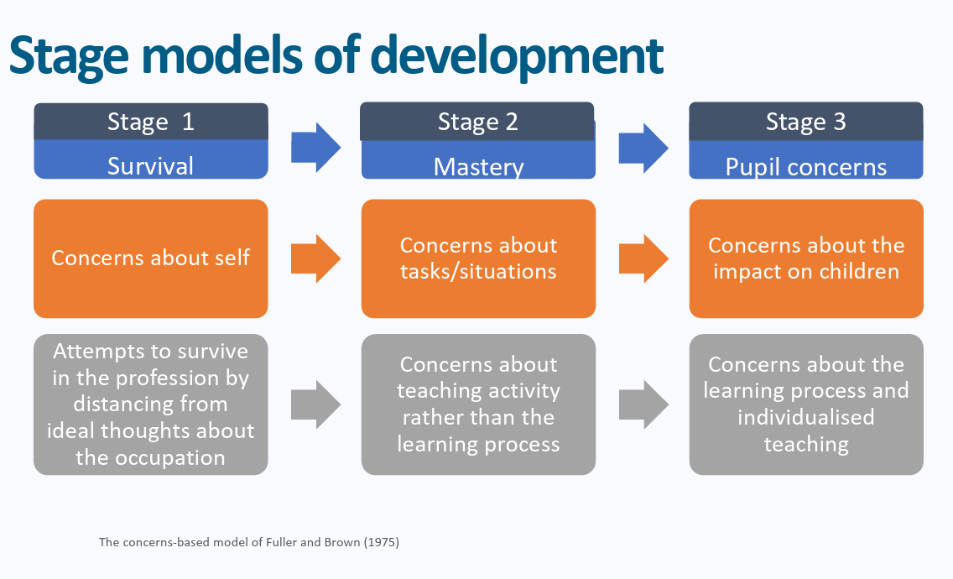
Professional Studies and ITAP content mirrors these stages by beginning in September with a focus on language, routines and presence and gradually increasing in complexity throughout the year.
How do I frame mentor meetings to follow up ITAP if I wasn’t in school or university sessions with my BT?
BTs can share their observations of colleagues in their ITAP schools and any feedback on their delivery of a tutor time via their OneNotes.

They should use this as a basis for reflection with you using the weekly paperwork and framework for discussion, to make links and reflect on different areas of the curriculum in exactly the same way as they would when reflecting on their Friday sessions.
My BT is quite general in their reflections. It is more about what they have done rather than what they have learnt.
When observing lessons during ITAP BTs will have a specific area of focus. For this ITAP it was what assessment methods were used at different stages of the lesson and what information each method gave BTs. BTs had a structured observation framework to guide their focus and so prompting them about specific details from the grid may help to facilitate their thinking and reflection.
How can I structure my follow-up reflection conversation?
Try to encourage BTs to give specific examples of what they have observed rather than generalised comments.
- What specific AfL techniques were used at different stages of the lesson (e.g., retrieval practice at the start, mini-whiteboards mid-lesson, exit tickets at the end), and why was each method chosen for that specific moment?
- Which AfL method did you observe/learn about that provided/can provide the teacher with the clearest, most immediate picture of whole-class understanding?
- What considerations may you need to bear in mind for pupils with SEND e.g. some pupils may require more processing time to be ready for what is coming next or when thinking of answers.
- How will you introduce and train your students to participate in AfL routines you haven’t used as much (like using mini-whiteboards effectively or self-assessing against success criteria) so these techniques run smoothly?
- How will you ensure that the feedback you give during your ITAP follow up lesson leads to immediate pupil action or correction, rather than just being passive information?

What are the set follow up tasks?
Beginning teachers should:
Be observed teaching a lesson with the ITAP focus: for this ITAP this will be on assessment and the focus should be on the appropriateness of the methods of assessment – for example, were whiteboards the best way to assess whole class understanding in the middle of the lesson or need to be used could targeted questioning have been more appropriate and saved pace? Did the whole class need to write answers at this point?
Practise providing meaningful feedback to pupils in both verbal and written form over the remainder of the term.
Discuss what beginning teachers know and understand about Coe’s poor proxies for learning listed below and ask beginning teachers to consider how learning can be assessed during a lesson.
1. Students are busy: lots of work is done (especially lots of written work).
2. Students are engaged, interested in learning and motivated.
3. Students are getting attention from the teacher through feedback and explanations.
4. Classroom is ordered, calm, under control and students are well behaved.
5. (At least some) students have supplied correct answers.
A summary of these can be found here: https://static1.squarespace.com/static/5c47c0b3e17ba324ad0c9d7f/t/68059f2ff006790ff263d0f5/1745198899260/Poor+Proxies+for+Learning.pdf
Please note that the follow up ITAP observation is on the w/c 30th November. I have attached the form to the email with some prompts for mentors to focus on the same areas in BTs teaching as they focused on during their assessment ITAP.
Please use the principles of instructional coaching from mentor training when feeding back on the ITAP lesson with a focus for development linking to one of the three core areas above:
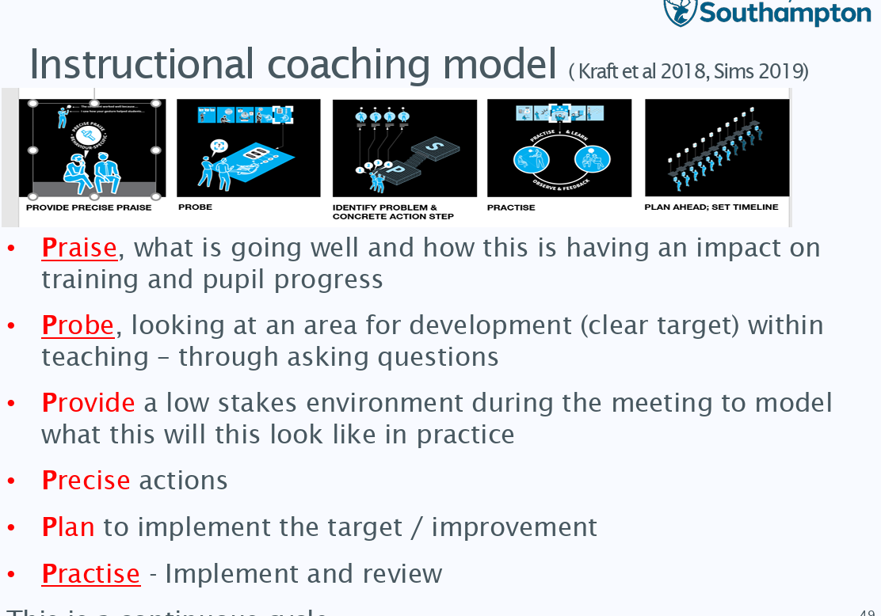
The observation form from the week commencing 30th November should be uploaded to BTs Onenotes as with their usual observations.
How can ITECs contextualise this further in school-based Professional Studies?
W/C 1st December
Beginning teachers could:

Discuss with an expert colleague, what data systems are used in school and how national data systems are used to track school performance – an outline of how pupils’ targets are set for KS3 and GCSE would be helpful in contextualising assessment from a school’s perspective.

W/C 8th December
Discuss with an expert colleague what internal assessment systems are used in school – read the marking policy and assessment policy and discuss why these have been designed in this way.

How are key assessment points decided and why?
How do staff ensure consistency when reporting assessment data?

W/C 14th December
As the DAD tasks on Friday 19th December will focus on supporting pupils with weaker literacy and numeracy in subjects, ITECs or an appropriate expert colleague could discuss the data received by schools about Year 7 pupils. What information is received and what does this tell schools? Are there any particular features of this year’s Year 7 cohort for your school? What are standardised scores and what support is in place for pupils with weaker literacy or numeracy?

