I haven’t been part of the planning for ITAP – how can I understand what it is and what the thinking was behind it?
ITAP is a core part of our curriculum offer. During Level 1 training the core ideas behind our curriculum design and sequencing was discussed in relation to ideas about how beginning teachers often learn and develop from concerns with self and looking inward to moving outwards in their thinking and considering pupils and pupil learning:
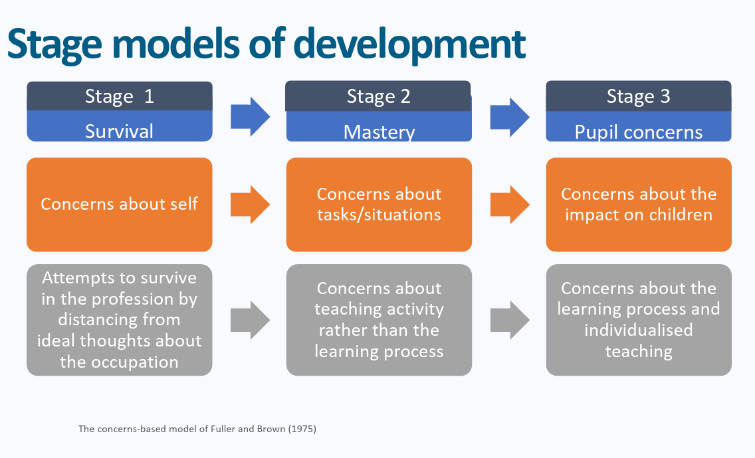
Professional Studies and ITAP content mirrors these stages by beginning in September with a focus on language, routines and presence and gradually increasing in complexity throughout the year.
How do I frame mentor meetings to follow up ITAP if I wasn’t in school or university sessions with my BT?
They should use this as a basis for reflection with you using the weekly paperwork and framework for discussion, to make links and reflect on different areas of the curriculum in exactly the same way as they would when reflecting on their Friday sessions.
When observing lessons during ITAP BTs will have a specific area of focus. For the adaptive teaching ITAP this was on planning for adaptive teaching:
Scaffolding Reflection Tool
Teaching to What Students Have in Common (pages 1-2 in particular)
What Makes Great Teaching? (Pages 2-4)
BTs had a structured framework to guide their focus in particular scaffolding.
Prompting them about the specific detail may help to facilitate their thinking and reflection.
- How did expert teachers identify individual learning barriers without lowering the learning goal for those pupils?
- What specific temporary supports such as modelling did you observe, and how did the teacher plan to fade them as pupils gained competence?
- How did teachers monitor learning during independent work, and what signals prompted them to adapt their delivery mid-lesson?#
- How can you build universal provision into your core delivery so that adaptations benefit the whole class rather than creating separate tasks?
- Pick one pupil in your placement class who receives targeted support: how will you ensure your scaffolding helps them access the high-level task without doing the heavy cognitive lifting for them?
What are the set follow up tasks?
Beginning teachers should:
Develop the ITAP content by team teaching one of your classes with your Mentor. Allow your Mentor to guide on moments where the lesson would benefit from adapting your approach slightly e.g. re-framing questions, providing more support for specific pupils. Discuss and deconstruct this afterwards as part of your teaching reflection for the week using the guidance below to help.
https://d2tic4wvo1iusb.cloudfront.net/production/eef-guidance-reports/feedback/Teaching-Learning-adaptive-teaching_practioner-tool_v.2.1.0.pdf
Read the guidance together and reflect on how adaptive teaching incorporates and builds on elements of previous ITAPs from assessment for learning. How does assessment for learning link to adaptive teaching?
Beginning Teachers can reflect on the following questions about their lesson:
How was the lesson structured to support all pupils to achieve the same challenging objectives?
Which pupils struggled in the lesson? How did you know this?
How did you ascertain what pupils knew and understood in the lesson?
What did you do when you realised some pupils were struggling?
How did you adapt your explanation or instructions?
Did you change your questioning based on pupil responses?
Did you provide additional scaffolds or modelling?

Please note that the follow up ITAP observation is on the w/c 19th April. I have attached the form to the email with some prompts for mentors to focus on the same areas in BTs teaching as they focused on during their adaptive teaching ITAP.
Please use the principles of instructional coaching from mentor training when feeding back on the ITAP lesson with a focus for development linking to one of the three core areas above:
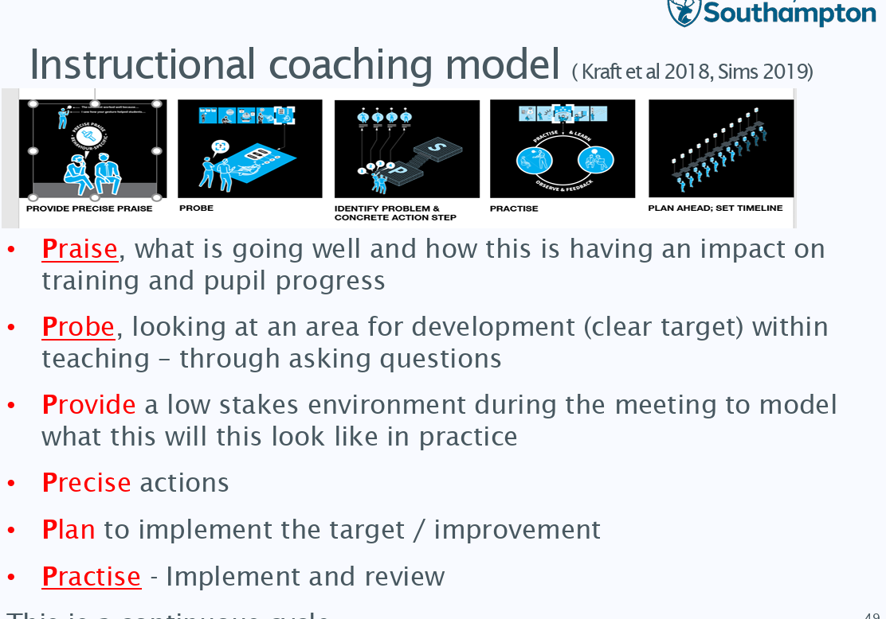
The observation form from the week commencing 18th April should be uploaded to BTs Onenotes as with their usual observations.
How can ITECs contextualise this further?
Joint Observation with ITEC
- Observe expert colleagues teaching with a focus on the ITEC deconstructing how they are identifying adaptive teaching methods used and their effectiveness in a lesson – particularly scaffolding of tasks and modelling at this stage in the year. Identify how and where staff modelled thinking aloud as well as identifying good practice. The ITAP observation form could be used for this to support discussion
- Choose two or three strategies to follow up in more detail (e.g. observing an intervention class with EAL pupils – conduct a pupil trail for other EAL pupils outside of ITAP to look at their experience through the day)
- Meet with any specialist EAL TAs to discuss their approaches with pupils and the theory underpinning this.
Joint observation with EAL Coordinator
- Observe an expert colleague with beginning teachers – focus in particular on identifying how you would identify the learning taking place in the lesson – this will again help draw together the focus on high quality teaching that runs throughout the Professional Studies programme. Re-visit the content from the beginning of the placement on observing lessons and discuss what high teaching “looks like”. How can you “see” this over time?

- Observing with an EAL Coordinator would be of particular value and can develop ITAP particularly when deconstructing how high-quality teaching enables pupils to make progress.

