I haven’t been part of the planning for ITAP – how can I understand what it is and what the thinking was behind it?
ITAP is a core part of our curriculum offer. During Level 1 training the core ideas behind our curriculum design and sequencing was discussed in relation to ideas about how beginning teachers often learn and develop from concerns with self and looking inward to moving outwards in their thinking and considering pupils and pupil learning:
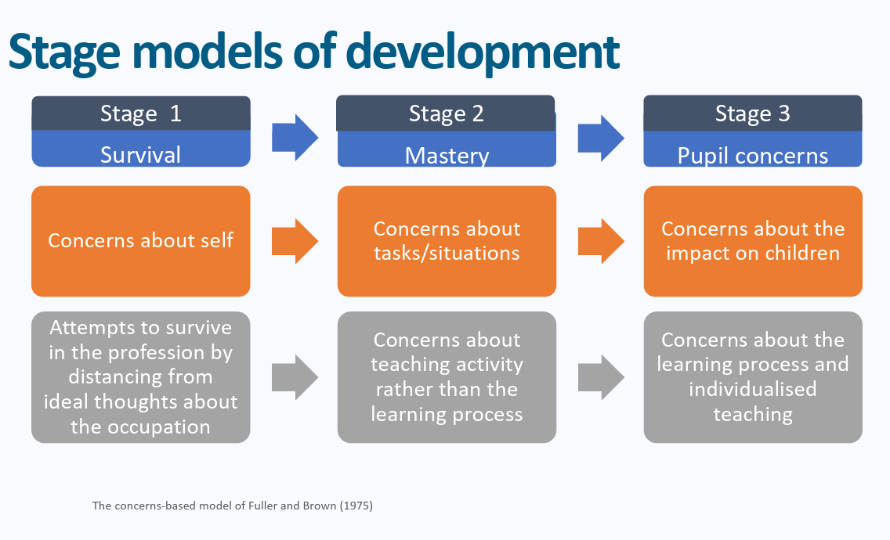
Professional Studies and ITAP content mirrors these stages by beginning in September with a focus on language, routines and presence and gradually increasing in complexity throughout the year.
How do I frame mentor meetings to follow up ITAP if I wasn’t in school or university sessions with my BT?
BTs have been asked to create a reflection document on their OneNotes to share with you– either a brief narrated presentation or a written document using the following structure to help them reflect on the week as a whole:
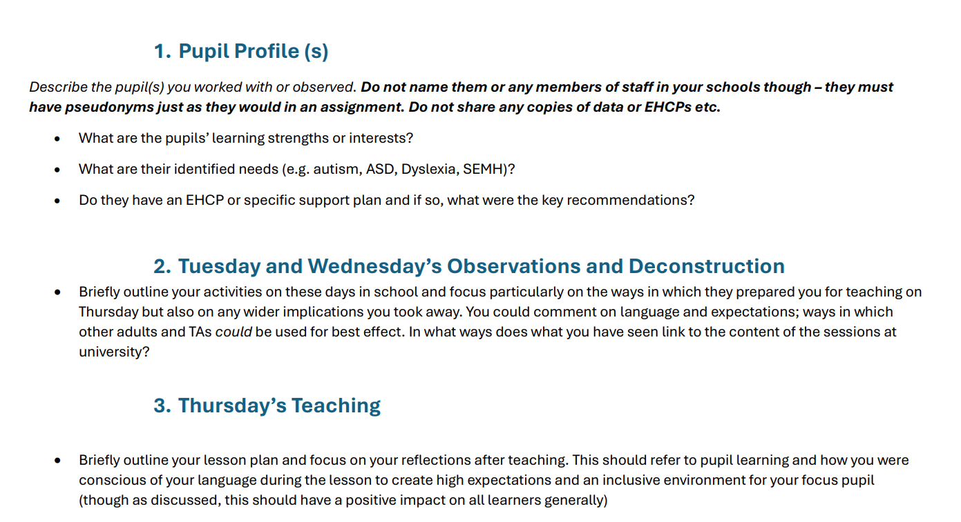
They should use this as a basis for reflection with you using the weekly paperwork and framework for discussion, to make links and reflect on different areas of the curriculum in exactly the same way as they would when reflecting on their Friday sessions.
My BT is quite general in their reflection handover. It is more about what they have done rather than what they have learnt.
The observation and deconstruction phase of ITAP mirrors the same principles of professional noticing outlined in mentor training.
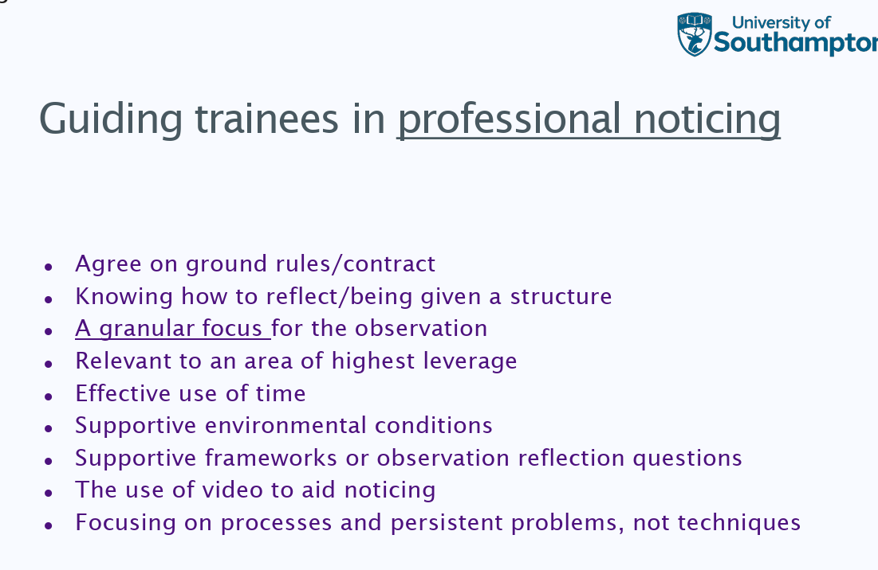
When observing lessons during ITAP BTs will have a specific area of focus. For the SEND ITAP this was on language – both written and verbal and framed around the EEF’s Five a Day strategies for all learners:
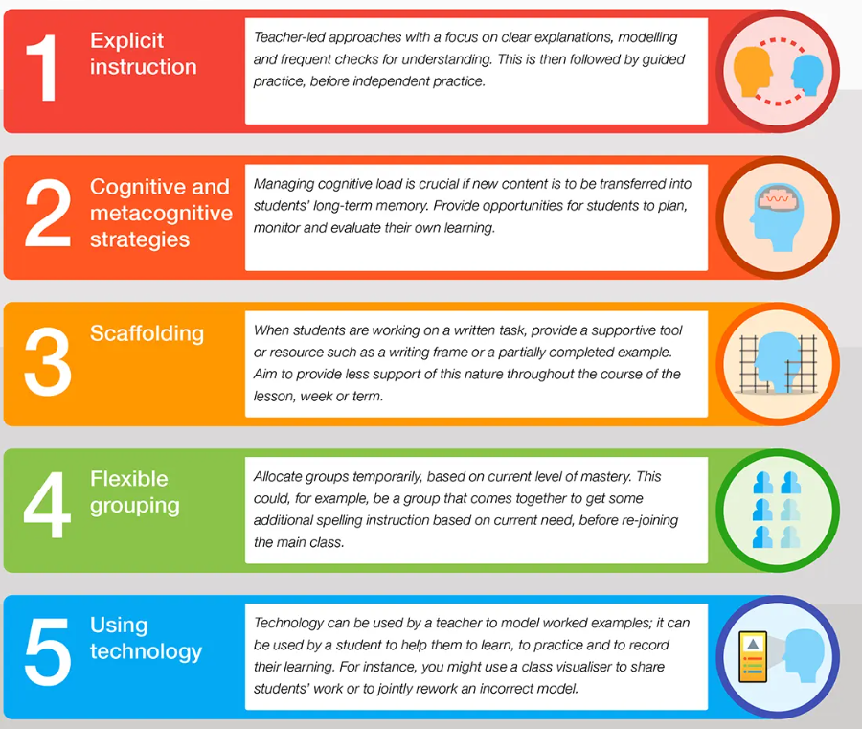
BTs had a structured framework to guide their focus in particular on points 1-3: explicit instruction- how did adults communicate expectations and instructions clearly to learners?
How was written and spoken language used in scaffolding and metacognitive tasks to support cognition and learning?
Prompting them about the specific detail may help to facilitate their thinking and reflection.
What are the set follow up tasks?
Beginning teachers should: Discuss how to work closely with the SENCO/ other professionals supporting pupils with additional needs, including how to make explicit links between interventions delivered outside of lessons with classroom teaching. This is likely to take place over several weeks and should begin with a discussion of previous learning from ITAP followed by a scrutiny of class lists to identify any pupils on the SEND register and to discuss strategies in place to support these pupils.
Discuss how educational software and technology can be used to support teaching and learning for pupils with SEND, taking some suggestions from the Nasen guide Ch5, to discuss and explore in more detail in relation to key students. Please note, this task could be re-visited as and when emerging needs appear. https://nasen.org.uk/assistive-technology
Please note that the follow up ITAP observation is on the w/c 2nd March. I have attached the form to the email with some prompts for mentors to focus on the same areas in BTs teaching as they focused on during their SEND ITAP.
Please use the principles of instructional coaching from mentor training when feeding back on the ITAP lesson with a focus for development linking to one of the three core areas above:
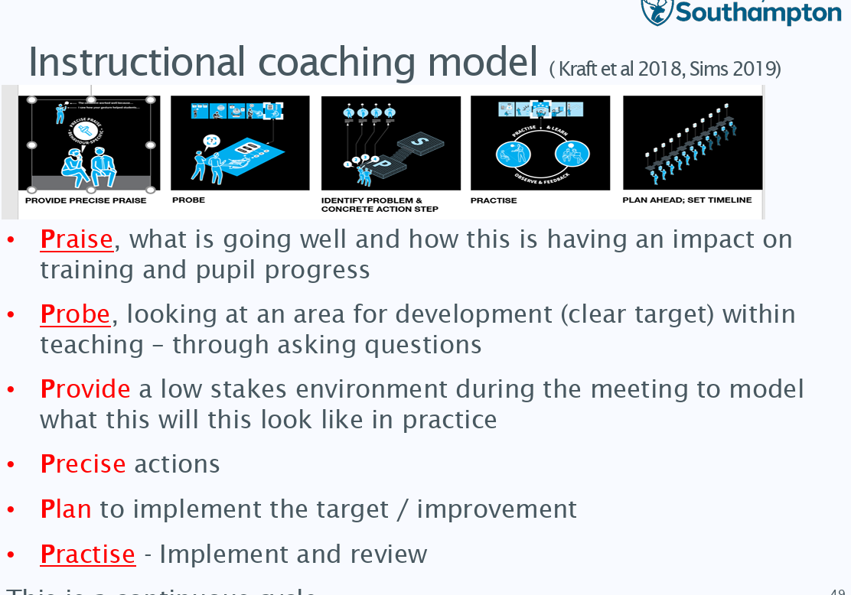
The observation form from the week commencing 2nd March should be uploaded to BTs Onenotes as with their usual observations.
How can ITECs contextualise this further?
BTs should discuss with the ITEC or relevant expert colleague e.g. SENCo how their focus placement school differed in terms of SEND need to their main placement. Areas for discussion could include the following:
- What are the overall pupil numbers in each school?
- What percentage of pupils are identified with SEND?
- How is information given to staff about pupils with SEND?
- Which categories of need are most common (e.g. cognition and learning, communication, SEMH, sensory/physical)?
- How are pupils identified as having SEND in each school?
- What outside agencies are involved in each setting (if known)
- How is pupil voice included?
- Are screening tools or assessments used differently?
- How are teaching assistants deployed in each school? Do they support individuals, groups, or the whole class?
- What interventions exist in each school and what do these look like?
- How do pupils with SEND participate in wider school life?
- What are the attainment and progress figures for SEND pupils?

