I haven’t been part of the planning for ITAP – how can I understand what it is and what the thinking was behind it?
ITAP is a core part of our curriculum offer. During Level 1 training the core ideas behind our curriculum design and sequencing was discussed in relation to ideas about how beginning teachers often learn and develop from concerns with self and looking inward to moving outwards in their thinking and considering pupils and pupil learning:
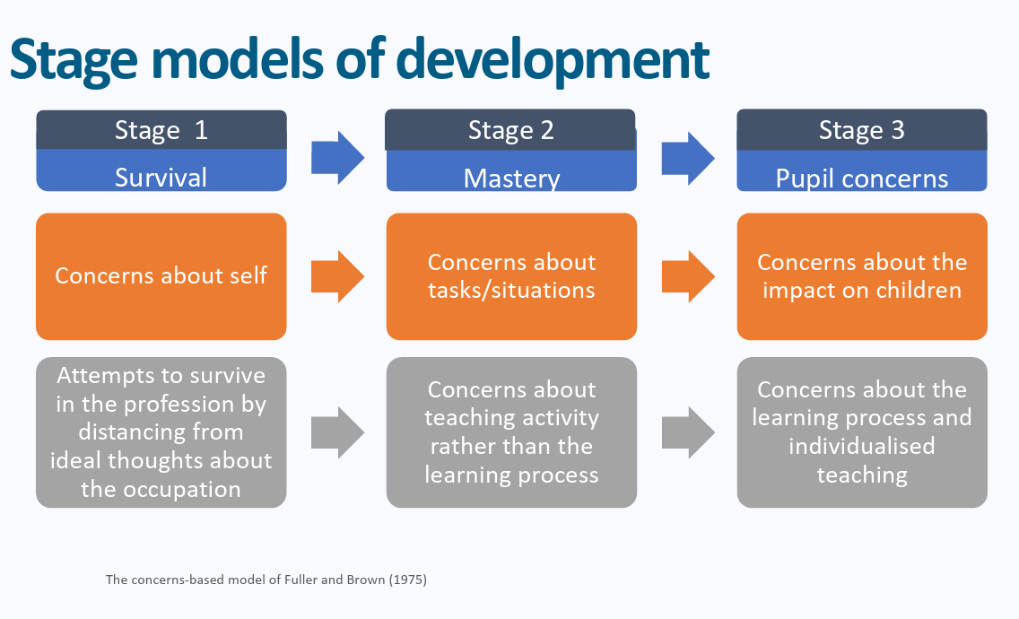
Professional Studies and ITAP content mirrors these stages by beginning in September with a focus on language, routines and presence and gradually increasing in complexity throughout the year.
How do I frame mentor meetings to follow up ITAP if I wasn’t in school or university sessions with my BT?
BTs can share their observations of colleagues in their ITAP schools and any feedback on their delivery of a tutor time via their OneNotes.

They should use this as a basis for reflection with you using the weekly paperwork and framework for discussion, to make links and reflect on different areas of the curriculum in exactly the same way as they would when reflecting on their Friday sessions.
My BT is quite general in their reflections. It is more about what they have done rather than what they have learnt.
When observing lessons during ITAP BTs will have a specific area of focus. For this ITAP it was what assessment methods were used at different stages of the lesson and what information each method gave BTs. BTs had a structured observation framework to guide their focus and so prompting them about specific details from the grid may help to facilitate their thinking and reflection.
How can I structure my follow-up reflection conversation?
Try to encourage BTs to give specific examples of what they have observed rather than generalised comments.
- In an all-through setting, how did the academic expectations and subject-specific depth in KS2 align with what pupils will face in Key Stage 3? Where did you see clear foundations being built early?
- How did teachers during your ITAP build a culture where primary pupils were comfortable struggling with hard concepts, and what language did they use to encourage perseverance?
- What specific strategies did you see used in KS2 to stretch higher-attaining pupils such as open-ended questioning, problem-solving variations, or conceptual depth that went beyond just giving them extra work?
- Now that you've seen the depth expected at KS2, how can you use that insight in your placement school and as an ECT to ensure your high expectations build on what pupils have learned previously?
- How were pupils with SEND challenged and supported?
- Although the curriculum is important, what other considerations did the experience highlight when thinking about how to support transition?

What are the set follow up tasks?
Please note that the follow up ITAP observation is on the w/c 14th June. I have attached the form to the email with some prompts for mentors to focus on the same areas in BTs teaching as they focused on during their ITAP.

Beginning teachers should:
Discuss the article on vocabulary (Ch2, available on Blackboard and the Partnership website) with your Mentor. How far does this resonate with your experiences of teaching Year 7 so far?
Observe an intervention session with Year 7. How are other adults supporting pupils’ progress during these sessions?
The ITAP observation focus for this should be on w/c Monday 14th June.

Please use the principles of instructional coaching from mentor training when feeding back on the ITAP lesson with a focus for development linking to one of the three core areas above:
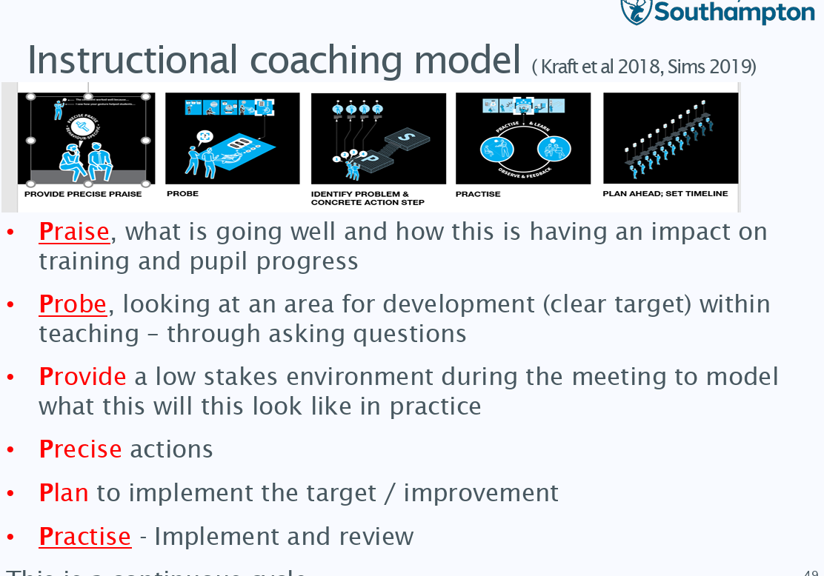
The observation form from the week commencing 14th June should be uploaded to BTs Onenotes as with their usual observations.
How can ITECs contextualise this further in school-based Professional Studies?
How can ITECs contextualise the final ITAP ahead of the end of the course on Friday 25th June?
Please note that some schools will set their own tasks which are different to those below – the purpose of these suggestions is to give schools a range of possible activities to pick from in order to contextualise the Professional Studies curriculum in their setting.
Beginning teachers could…
- Look through a range of Year 7 exercise books – discuss with ITEC what they can elicit about expectations from a range of pupil work. Looking at the books of 2 or 3 pupils over several subjects can provide interesting discussions for consistency and expectations across different subject areas in terms of marking and literacy/numeracy support.
- Take one pupils’ journey from their transition in Year 6 to deconstruct with an expert colleague: discuss what information was available at the point of transition, what their initial data were suggesting about ability and then track through SIMS/Classcharts (or equivalent) their assessment and behaviour points throughout the year – identify the progress that they have made overall and any areas where they appear to have struggled. What support was put in if necessary, from secondary school and how has this improved their outcomes?

