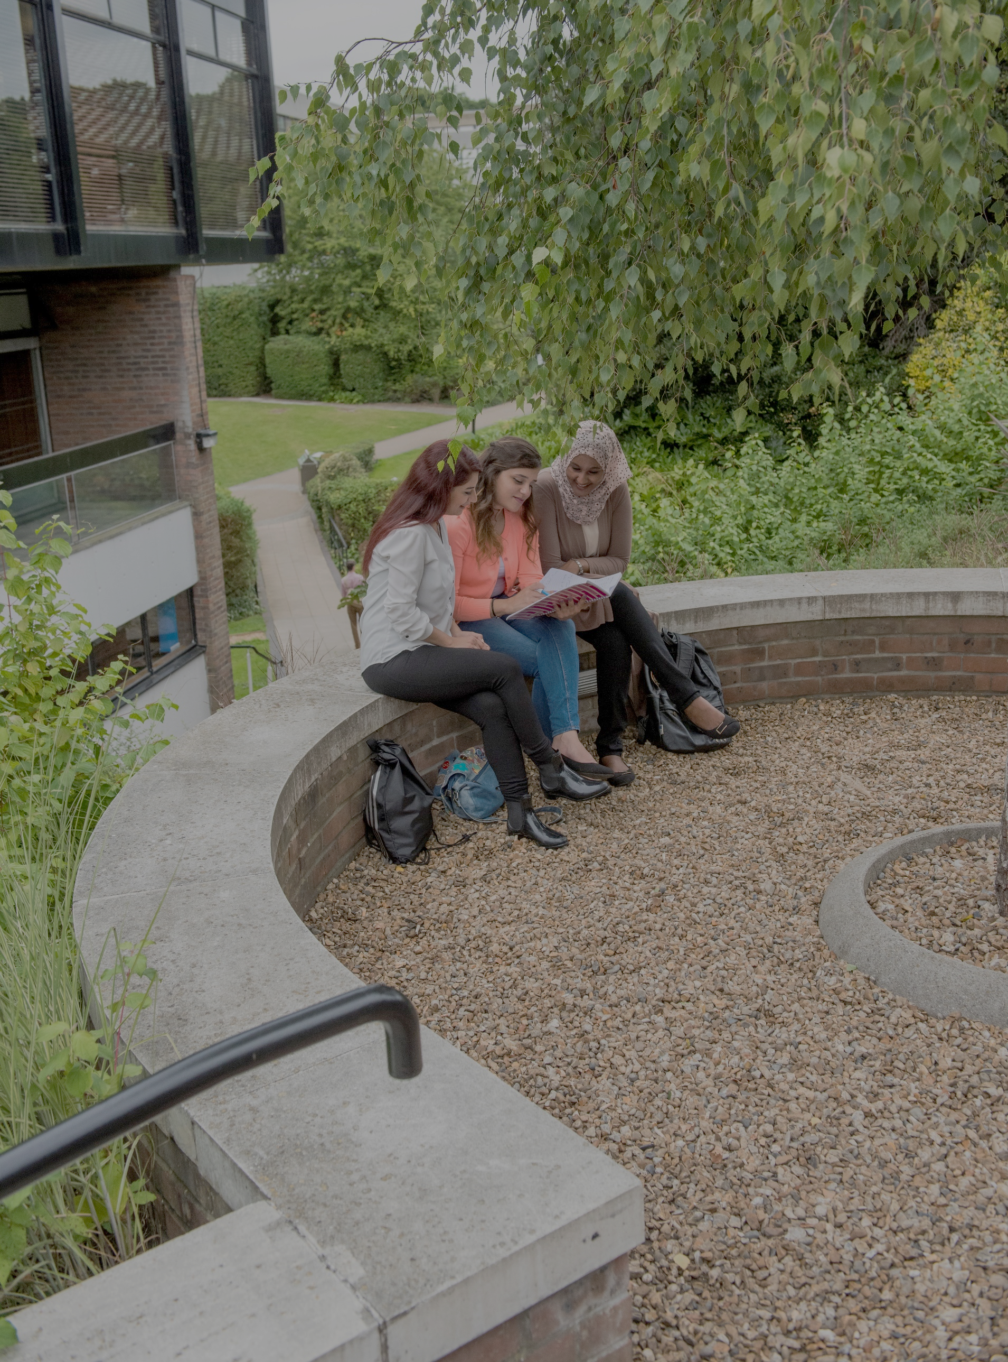

Pre-teaching phase
Main Placement Induction Tasks
2026-2027
PGCE (Secondary) Programme

Susan Fishlock: Professional Studies Lead, PGCE Secondary.

School-based task list
All beginning teachers should complete the yellow highlighted tasks, along with any associated pre-reading and reflections on the focus sheets in this booklet. These core tasks will follow up on the induction and ITAP weeks which focused on professionalism, planning and behaviour management; they will also serve as valuable induction tasks so that you are prepared with as much contextual information as possible about the school before you begin teaching.
You should also aim to complete as many of the blue highlighted additional tasks as possible; please discuss which would be most appropriate with your Mentor or ITEC.
Date completed
Compulsory tasks
Compulsory informed observation tasks
Observe at least one lesson with a focus on lesson structure. How is the lesson designed to maximise student engagement and learning? See focus sheet 1. NB: this could be with a class that you will be teaching after half-term.
Observe at least one lesson with a focus on the ways the teacher manages behaviour through creating a positive learning environment– see focus sheet 2. NB: this could be with a class that you will be teaching after half-term.
Observe at least one lesson with a focus on how the teacher checks for student understanding in order to maximise student engagement and learning– see focus sheet 3. NB: this could be with a class that you will be teaching after half-term.
Observe at least one lesson with a SUBJECT SPECIFIC FOCUS – see focus sheet 4 as an MFL example. NB: this could be with a class that you will be teaching after half-term.
Compulsory school document-based tasks
Look through copies of departmental schemes of work for the classes you will be teaching. Fill out your subject knowledge audit with the areas will you need to focus on. NB: it might be useful to mark on your timetable when you will be reading/observing in school during some free periods with guidance from your Mentor.
Read through the school’s behaviour policy. Annotate the ways in which it encourages a positive approach to behaviour management. Which key stakeholders are involved? What routines, sanctions and rewards does your school use? Do these routines involve the use of any specific language?
Read through the school’s safeguarding procedures/attend relevant training as requested by your ITEC
Compulsory discussion tasks
Discuss with your Mentor (and possibly other colleagues) how they make time for rest and recovery. How do they support each other as a team? What strategies for managing workload can they suggest for you as a beginning teacher?

Compulsory ITAP application task
Continue to apply learning from ITAP in a different context by (at least once) leading either an entry or exit routine into a classroom. Those feeling more confident may wish to lead an activity or part of a lesson. This should only be informally observed with notes to inform the fortnightly reflection task on OneNote during the w/c 12th October. The formal follow up is W/C 2nd November once BTs have settled in.
Additional, Optional, observation tasks (to be decided in discussion with Mentors)
Observe a range of teachers who have established presence in very different ways. It would be particularly useful to focus on use of voice, tone and body language in these observations.
Co-observe a lesson or part of a lesson alongside your Mentor or another expert colleague with a focus on how the teacher manages behaviour (it will be useful here for colleagues to be able to deconstruct factors like what routines are in place; how these may have been established, how the teacher uses language e.g. positive reinforcement, targeted praise and encouragement etc.)
Observe members of your department teaching – again, with a focus on use of voice, presence, language and routines.
Additional, Optional Discussion based tasks (to be decided in discussion with mentor)
Discuss with a teacher/your Mentor how they approach(ed) the planning of a lesson that you have or are going to observe. How do they structure their lessons? How do they use their scheme of work? What key elements do they consider in their planning?
Discuss with a teacher who is a tutor or a pastoral leader. How does the school aim to promote student wellbeing? In what ways do they promote the ideas of inclusion and diversity? How do they develop core personal skills and attitudes to learning?
Additional, Optional Documentation Tasks (to be decided in discussion with Mentors)
Read through any data/documentation for the classes that you will be teaching in order to familiarise yourself with pupils’ prior attainment and any SEND needs that you may need to be aware of at this stage (remember that you are not formally assessed for putting adaptive teaching into practice until after Christmas)
Read through a sample of pupils’ exercise books from classes that you will be teaching, in order to familiarise yourself with the range of ability in your classes.
Read through any exam/assessment papers and/or specifications to develop your subject knowledge in these areas. Begin to familiarise yourself with the key content for KS3 and 4. What core skills and knowledge are developed? Make a list for each year group.

Use the above tasks as a focus for Mentor reflective discussion at the end of the first week (see discussion prompt sheet at the end of this booklet).
Signed Mentor: __________________________________________________
Signed Beginning Teacher: __________________________________________________

Focus Sheet 1: Observe 1 lesson with a focus on lesson structure. How is the lesson designed to maximise student engagement and learning? | ITTECF links:  Learn that: 2.2; 2.3; 2.4
- Induction reading (to recap ideas from before the lesson): Sherrignton, T. & Caviglioni, O. (2020) Teaching WalkThrus: Five-step guides to instructional coaching Woodbridge: John Catt (Curriculum Planning)
Lesson prompt questions:
- What is the context of the class? What year group/ability/class size?
- Is there a seating plan? How does this seem to have been decided?
- What was the objective of the lesson? How was this communicated to pupils?
- How does the lesson link to prior/future learning? How were you able to know this?
- How were activities sequenced to help pupils to achieve the L.O? Complete the grid below to help with this...
- Do all pupils complete the same tasks? Is there any variation at all and why might this be?
- Does the teacher vary their language at all? When does this happen and why?
- If there is a TA in the lesson, what are they doing? How do they contribute to the learning?

In lesson task/space for note taking:

Complete the grid below, using the example to guide you. It is fine to write that you are not sure how something links to the objective; that is the whole point of unpicking this with your mentor afterwards.

Time | Activity | How does this link to the objective? | How does the teacher ensure that pupils are on task during this?
9.05-9.15 | Pupils complete retrieval task based on ‘literary devices’ | Pupils will be analysing a poem so this reminds them of key techniques that they might use today | Teacher has the qs and instructions on the board so everyone knows what they should be doing, he moves around room to check everyone is on task.

Space for notes on prompt questions and any additional questions/thoughts that you may have:

Post lesson reflection
Consider the way that the lesson was structured – how can this be linked to your reading during University subject sessions on Sweller and cognitive load?

If you were teaching the same lesson to a different ability group how might you have structured the lesson content differently? Would you have changed anything? If you find this challenging, pick one part of the lesson and explain how you may have changed this for a different ability group.

Focus Sheet 2: Observe at least one lesson with a focus on creating a positive learning environment. How does the teacher establish appropriate learning-focused relationships which maximise student engagement and learning? | ITTECF Links:  Learn That: 1.1, 1.3, 7.1, 7.2
ITAP Reading (to recap ideas from before the lesson):
- Grossman P, Hammerness K and McDonald M (2009) Redefining teaching, re-imagining teacher education. Teachers and Teaching: Theory and Practice 15(2): 273–289.
Lesson prompt questions:
- How frequently are names used? When are names used? How does this effect the lesson?
- How does the teacher use their tone of voice help to create a positive learning environment? Did the teacher use tone of voice and body language to encourage pupils to engage in learning?
- Are clear expectations communicated during the lesson? Where were these expectations reinforced?
- When is positive reinforcement, encouragement and affirmative language used?
- Does the teacher use clear routines in the lesson? Are routines used to gain whole class attention? Do pupils know what to do, what to bring, how to respond through the lesson due to clear routines?
- Were there agreed consequences/choices as part of the behaviour management system evident in the lesson? Where these used in the lesson? Why were they used? What was the outcome?
- How does the teacher reduce distractions through the lesson design (e.g. keeping complexity to a minimum do that attention is focused on the content)

General reflections on prompt questions | Additional questions that you may have for your mentor:
Post lesson reflection

- Consider what routines were in place and how these may have been taught. How can this link to ideas from your ITAP reading?
- How did teachers use different styles of tone and body language in lessons observed?

- Creating a positive learning environment for all pupils requires establishing appropriate learning focussed relationships with high expectations and where everyone knows the routines and boundaries. Bullet point 5 takeaway points in readiness for when you teach a class:

Focus Sheet 3: Observe at least lesson with a focus on how the teacher checks for student understanding. | ITTECF links: 1.4, 1.6 , 7.1
- ITAP reading to recap ideas from: Promoting behaviour for learning in the classroom: Effective strategies, personal style and professionalism. Ellis and Tod (2015) Chapter 3. Available as an ebook through University library.
Lesson prompt questions:
- How does the teacher use praise and reward? Can you give an example of where you feel the teacher used “targeted praise and encouragement”?
- Give an example of where the teacher gives manageable, specific instructions. How do they keep instructions concise and memorable? Do they use voice/pitch/non-verbal gesture to help here?
- How does the teacher follow up if pupils have not begun a task? What interventions do they make?
- What does the teacher do if students have not understood something?
- What techniques do teachers use to be able to assess how well a whole class have understood? (some ideas: hands up, mini whiteboards, think, pair, share, hands down questioning etc.)
- How do you think the teacher may carry forward information on student progress from this lesson in their future planning – if you can, ask them!
- In what ways does the teacher offer feedback to students to help them advance in their learning?

General reflections on prompt questions

In what ways did the teacher you observed find out about a) pupil progress and b) pupil difficulties. Try to give specific examples from what you saw. Why were these strategies effective? | Questions from what I have observed to ask my Mentor:
Post lesson reflection: What did you notice, why was it interesting to you, what will you do next as a result?

Think about the input you have received at University on the psychology of behaviour and how pupils learn. Where did you see these ideas manifested practically during the lesson? How did this combine with behaviour management strategies used to create an effective climate for learning?

Focus Sheet 4: SUBJECT SPECIFIC FOCUS: choose one of the subject-specific themes that were introduced during your ITaP week | ITTECF Links: Standard 2: How pupils Learn (Promote Good Progress) 3.2
Subject-specific Pre-reading (to complete before the lesson): Link your focus to a piece of subject-specific reading you’ve been given
Lesson prompt questions (make a list of 6-8 points that you will focus on during your lesson observation):

In lesson task:
1) Make notes on the lesson prompts above.

Post lesson reflection

Reflective Discussion with Mentors
At the end of the week, you will have a reflective meeting with your Mentor where you will draw together your reflections from the compulsory observations and discussions. Whilst you may well talk about other things, the prompts below should form the basis for this conversation:
- How did you feel before the days compared with your feelings now? Are there any questions or immediate issues that you want to talk through?
- Share your findings from the observations and talk through your responses.
- How does what you have seen in classrooms feed into what you have covered in university? This should cover subject, Professional Studies and ITAP sessions. Remember that your Mentors will have received the updates about what we have covered in University sessions but you will need to be articulating the links between this and what you have observed in school(s).
- What good practice have you seen in school that has already had an impact on your development as a beginning teacher? Remember, it is a very short time, and we are not expecting you to suddenly feel confident teachers – this is about developing you as reflective practitioners.
- What good practice have you seen that will/could have an impact on your development as a beginning teacher when you start teaching?
- What have you noticed about workload and resilience? Are there any challenges that you can foresee when you begin teaching?
- Any questions that you would like to ask regarding beginning teaching?
Reflection
Use the notes you have made in this booklet and the content of the Mentor conversation above to complete a reflection on your experience this week.
- What have you found most interesting? Why?
- What have you seen in action that you have discussed previously at University?
- Have your perceptions changed?
- What would you like to find out more about?

